

**American International University- Bangladesh**

**CSC 3215: Web Technologies**

**CO2 and CO4 Evaluation**

**Finished Project Report**

**Spring 2021-22**

**Project Title: Hospital Emergency Services and Management System**

**Section: E**

|  |  |
| --- | --- |
| Student Name | Student Id |
| Mehadi Hasan Reaz | 20-42841-1 |
| Md. Abrar Hamim | 20-42832-1 |
| Pritom Debnath | 20-42414-1 |

**Project Description:**

*Hospital Occupancy is a system which focused on giving services to the emergency patients. The web application provides two main usages-*

* *ICU management*

*User would get to know the availability and details of ICU. The admin can update, insert and delete the data of ICU.*

* *Doctor Management*

*Users can view available doctor list and book appointment for doctors. The admin can update, insert and delete the data of doctor.*

*The main purpose of this system is to help the patients in time and give an easy way to get their needed services so that they don't have to run hospital to hospital. The project has patients as the audience and also it has a target market in which hospitals. Additionally, the use of this system is uncomplicated and sequential.*

**Project Folder Structure:**

*There are two folders named ‘Sources’ and ‘Style’.*

*Sources contains the images used in the projects. In the Style folder all the CSS file is there and in the main folder all the php file is located*

**Core Modules of the Project:**

***UserSignIn.php***

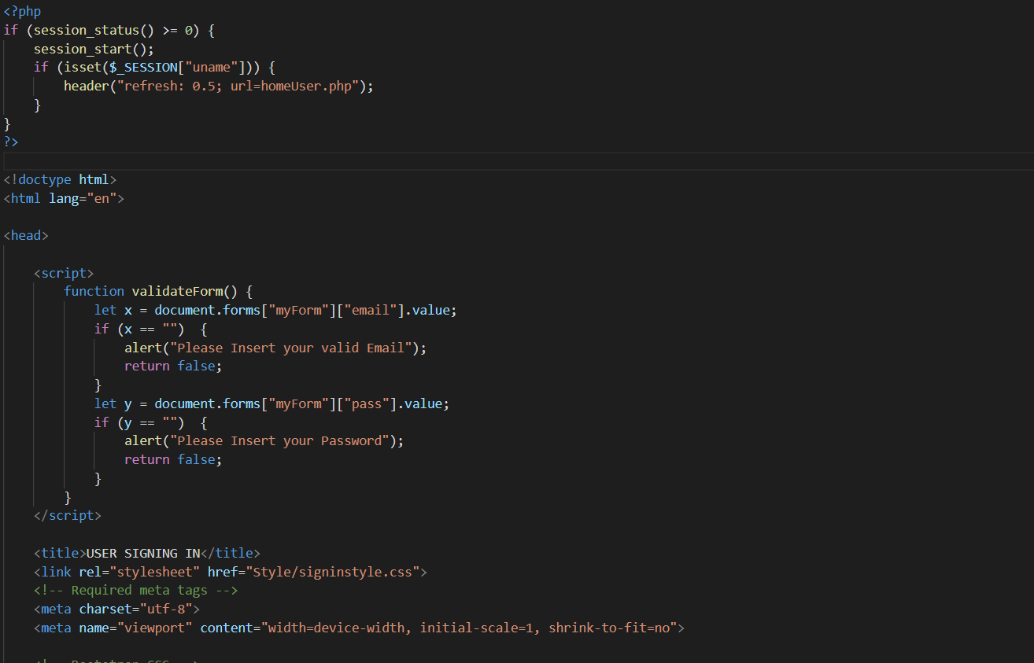

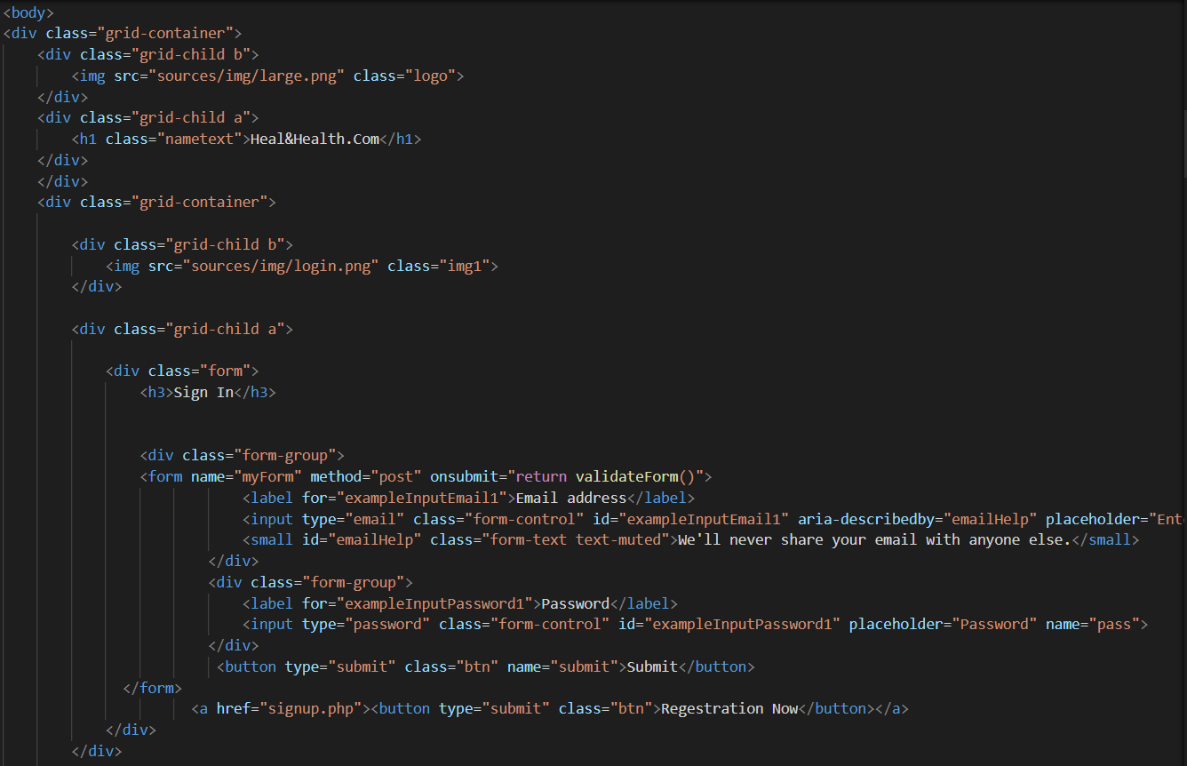

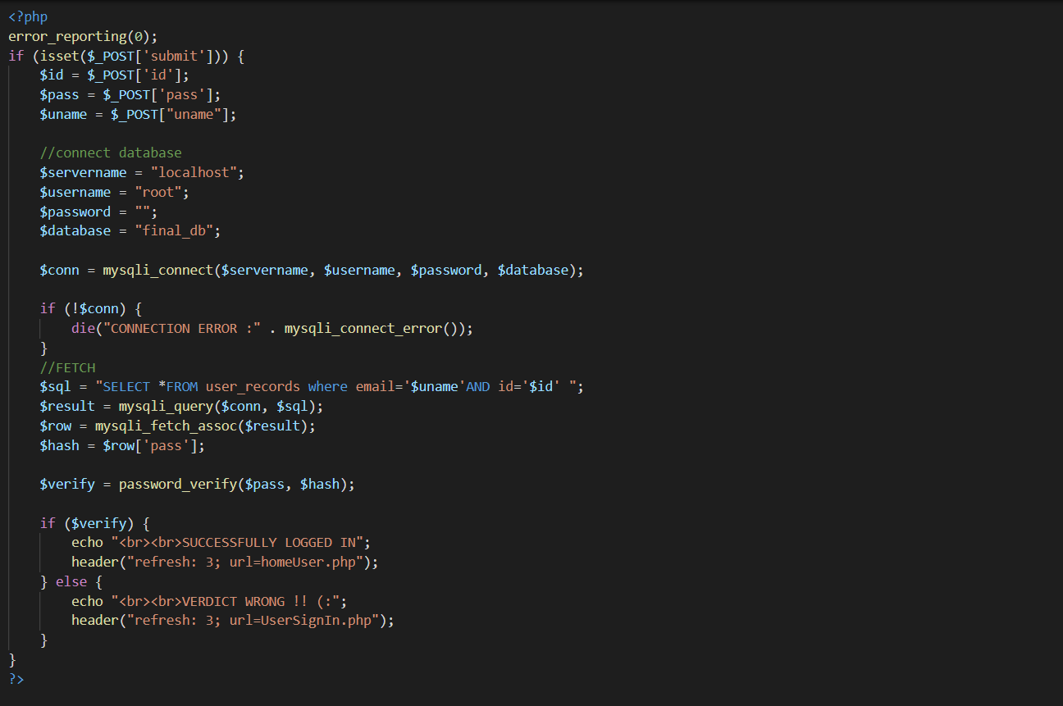

***UpdateIcu.php***

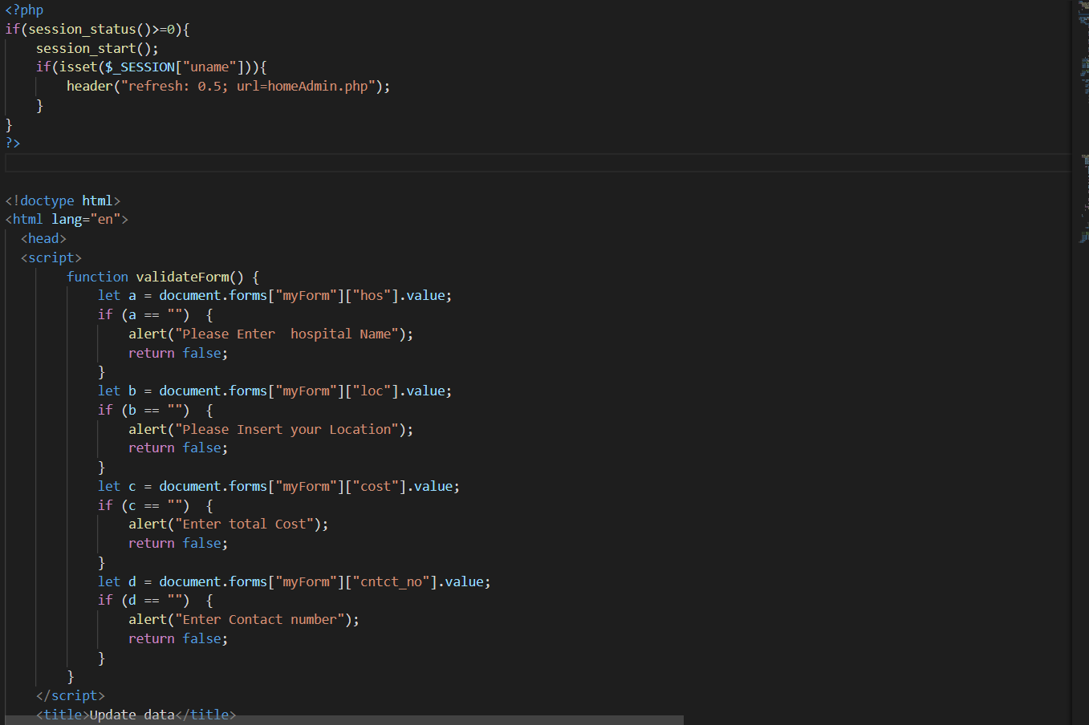

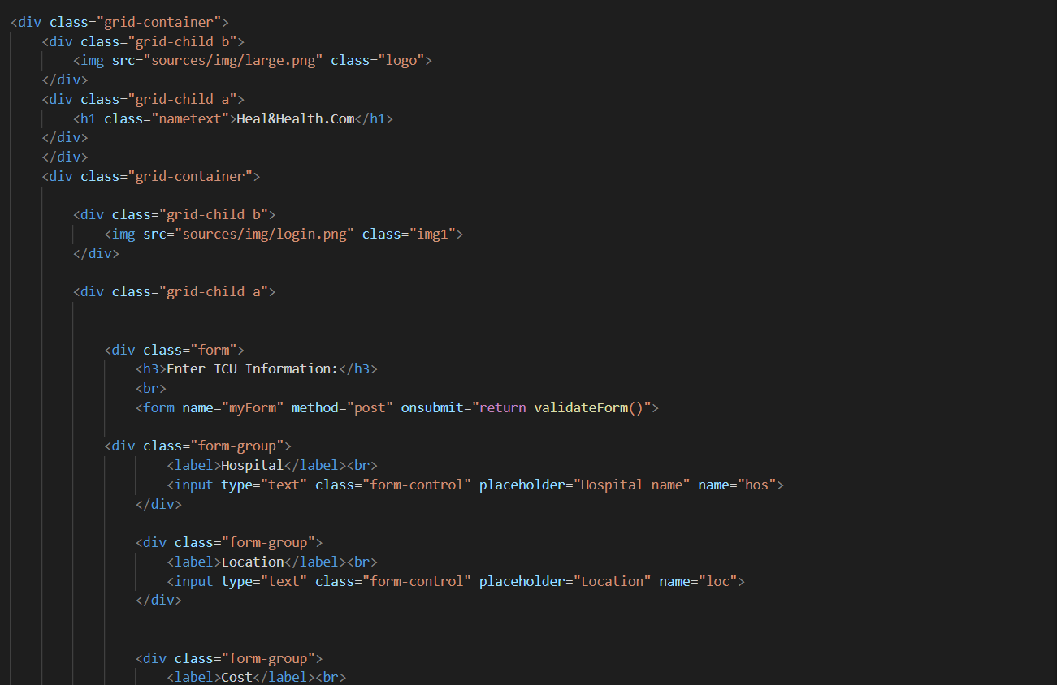

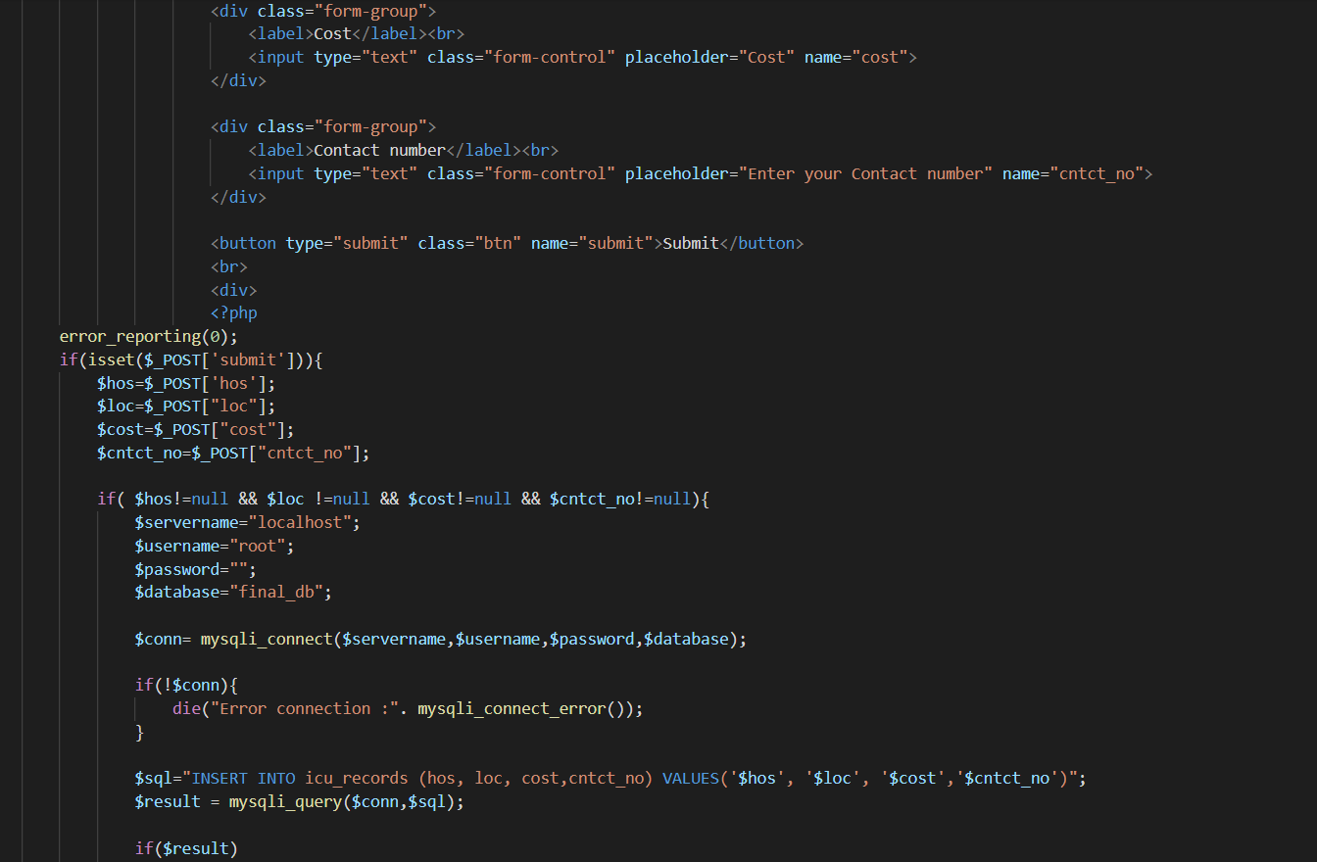

***showICU.php***

